**Team Encluders**

**BSIT 3301**

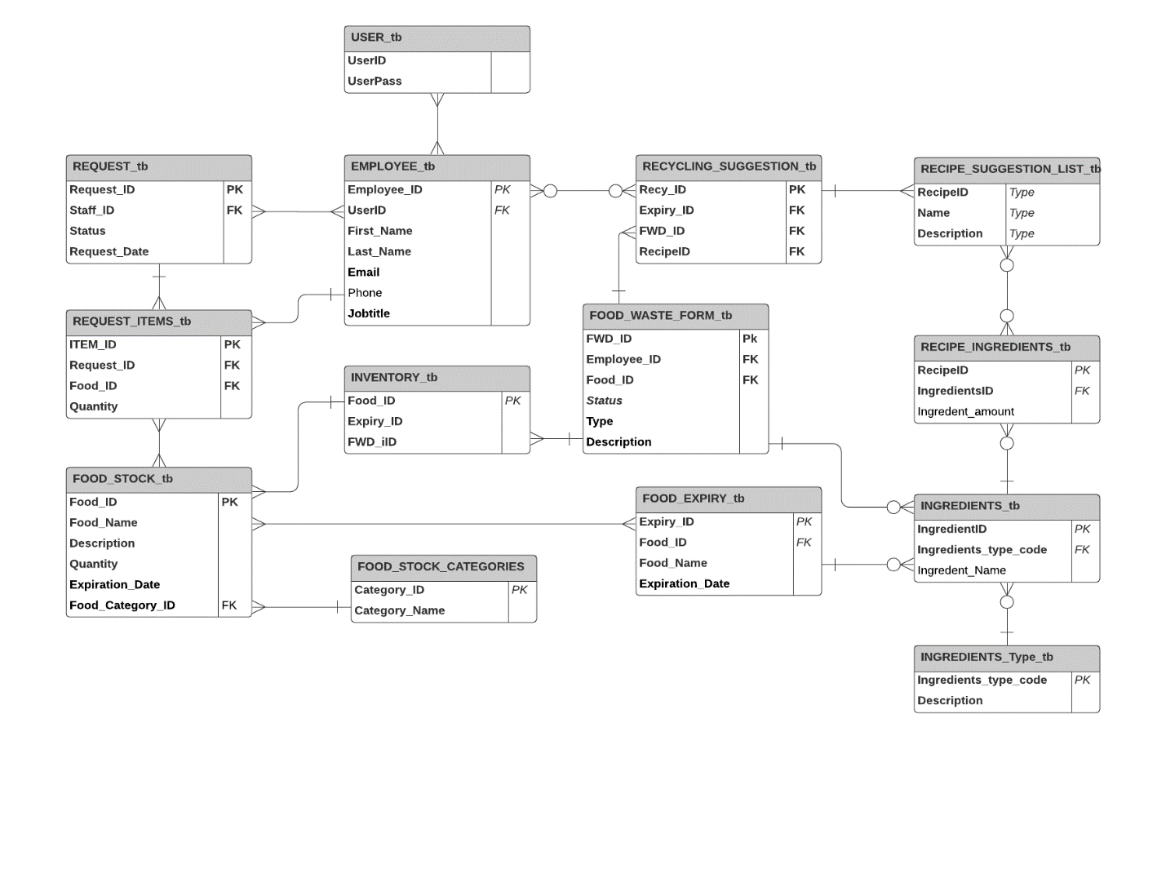**Revised Database Architecture**

**List of Queries**

SELECT * FROM REQUEST_tb; // This query show all tables from Request

show columns from FOOD_EXPIRY_tb; // Returns the columns and column information pertaining to the Food Expiry Table table

INSERT INTO USER_tb(UserID,Userpass) VALUES ('Daniel','Staff#231'); // insert data from table user

SELECT COUNT(*) FROM FOOD_WASTE_FORM_tb; // Count rows from table FOOD WASTE FORM

SELECT * FROM REQUEST WHERE StaffID = '4321' AND = RequestID '3444444'; // Show all records containing the StaffID = '4321' AND = RequestID '3444444'.

SELECT DISTINCT ITEMS_ID FROM REQUEST_tb; // Show unique records.